**JOIN YOUR COUNCIL!**

This May will see elections for all of the Parish Councils in Bucks, including Burnham.

We are very keen to attract dedicated and motivated members of the community to join the Council, helping to shape local services and providing a voice for its 13,000 residents on local and regional issues.

If you live or work in or around Burnham, and feel that you can bring skills and knowledge to support and strengthen the work of Council, please do consider standing. Particularly useful skills are a background in finance, public relations and marketing, event or project management, personnel, fundraising and development, facilities management, or social enterprise. The Council is at its strongest when it represents all parts of the community, and we are particularly keen to hear from those currently underrepresented, including young people, ethnic minorities, and the disabled.

We are not a party-political council, and all councillors work together for the benefit of the area and its residents. The best councils have a mixture of ‘old hands’ bringing experience and knowledge, and ‘fresh faces’ bringing new ideas and perspectives, so if you’re interested in joining us there is never a better time!

**What is the Parish Council?**

The Council is made up of up to 19 councillors, representing the residents of Burnham. The Parish Council is one of the two tiers of local government in Burnham – the other being Buckinghamshire Council. Each Council is responsible for providing a range of services and facilities to residents. The Parish Council’s responsibilities include:

* Community facilities such as Burnham Park Hall
* Parks and playgrounds including Burnham Park, St Peter’s playground, Hag Hill playground, The Stomping Ground, and the pond at Lent Green Lane
* The George Pitcher Memorial Ground pitches, nature reserve and trim trail
* Street furniture including benches, bins, and some street lighting
* Distributing funds for improving infrastructure from large planning applications
* Providing a voice for residents on regional and national consultations
* Reviewing planning applications and feeding back views to the District Council
* The Jennery Lane public toilets

If you don’t wish to stand for the council yourself, perhaps you know someone else who might and who would appreciate your encouragement and support in standing. Perhaps you can even think of someone who hasn’t thought about becoming a councillor but you know they would be great in the role because of their local knowledge, skills and experience, or love of Burnham.

**What do councillors do?**

As a councillor, you would shape the council’s plan, helping to make decisions on how local facilities and services are run and helping to set the budget, including the Parish Council part of Council Tax (the ‘precept’ which makes up 6-7% of your annual council tax bill).

The Council meets on a Monday evening roughly every 6 weeks. Councillors also serve on committees, which deal with specific issues such as planning applications or the management of Burnham Park Hall. As a councillor there is a variety of free training and support available, and opportunities to take on more responsibility, for example by helping to run a committee,

Although all councillors are expected to be active, it is not a huge time commitment - most councillors spend a few hours a week on council business, attending an average of three formal meetings a month, and spending other time reading emails or papers, or talking to residents. It is a non-paid position, but we do cover reasonable expenses.

**How to stand**

In order to stand for the council you have to meet eligibility rules, and to fill in a simple form before ‘nomination day’ which will be a few weeks before the elections in May. The form will be available from Buckinghamshire Council. This includes getting two local voters to sign to support you. Details can be found at <https://www.electoralcommission.org.uk/sites/default/files/pdf_file/Part-1-Can-you-stand-for-election-P-and-C.pdf>

**Why become a Burnham Parish Councillor?**

There are lots of benefits to becoming a Burnham Parish Councillor; it's a voluntary role that only takes a few hours of month; and lets you:

* Work for the direct benefit of the community of Burnham;

* Help shape and improve the council's services - including parks, playgrounds, pitches, streetlights, benches, events etc;

* Find out more about what's going on in the community and the council;

* Meet and work with others who have the same goal of improving Burnham for everyone.

* Access free training, and develop further skills - such as finance, communications, grant applications etc.

**What next**

If you, or anyone else, are interested in becoming a councillor you could:

* talk to a current councillor - the list is on our website under ‘Burnham Parish Council > Your Councillors;
* come to any meeting of the council, and even speak under the public participation session. The full list of meetings is on our website under the ‘Burnham Parish Council > Council meetings menu; the next full council meeting is 10th March
* look through our website, which has a lot more information on what we do.

**Democracy depends on you, so please do your part!**

**Where can I find out more information?**

Visit www.burnhamparish.gov.uk

Contact the Parish Clerk: 01628 661381 / clerk@burnhamparish.gov.uk

Write to Burnham Parish Council, Burnham Park, Windsor Lane, Burnham, SL1 7HR

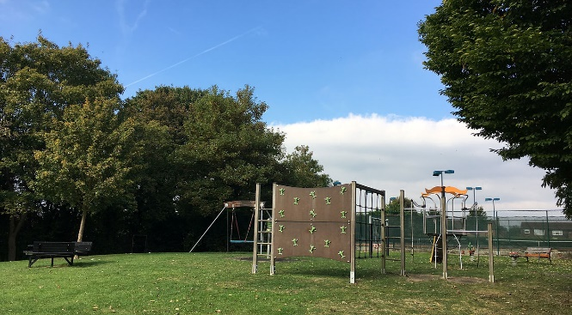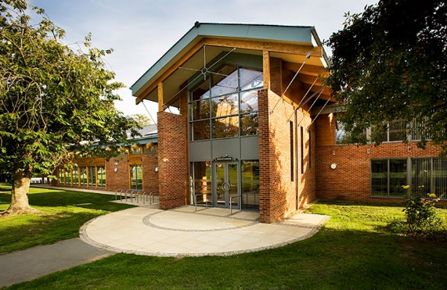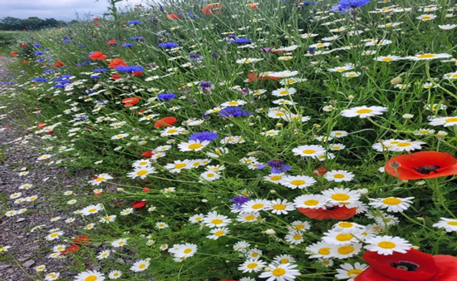

Wildflowers at the Cherry Orchard; Burnham Park Hall; Stomping Ground Play Area